**Pie Chart**

**What is Pie Chart?**

Pie chart is a type of graph in which a circle is divided into sectors that each represent a proportion of the whole.

The image below shows a pie chart based on research for Wildlife Population in 2017.

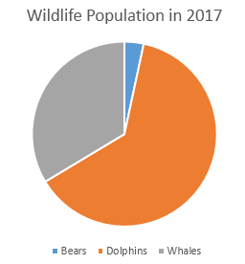

**How to create a Pie Chart?**

Imagine you survey your friends to find the kind of movie they like best:

|  |  |  |  |  |
| --- | --- | --- | --- | --- |
| **Table: Favorite Type of Movie** | | | | |
| **Comedy** | **Action** | **Romance** | **Drama** | **SciFi** |
| 4 | 5 | 6 | 1 | 4 |

1. First, we need to find the total of the data.

Add up all the numbers:

4 + 6 + 4 + 1 + 5 = 20

1. Next, find the percentage for each of the types by

**dividing the value by 20 and multiply by 100%.**

|  |  |  |  |  |
| --- | --- | --- | --- | --- |
| **Comedy** | **Action** | **Romance** | **Drama** | **SciFi** |
| 4 | 5 | 6 | 1 | 4 |
| (4/20) * 100% = **20%** | (6/20) * 100% = **25%** | (4/20) * 100% = **30%** | (1/20) * 100% = **5%** | (5/20) * 100% = **20%** |

1. Now, we need to divide the circle into “pie slice” for each of the topics.

We need to find the degrees for each sector by

**dividing the value by the total, 20 and multiply by a full circle which is 360°.**

We will get the result below:

|  |  |  |  |  |
| --- | --- | --- | --- | --- |
| **Comedy** | **Action** | **Romance** | **Drama** | **SciFi** |
| 4 | 5 | 6 | 1 | 4 |
| 20% | 25% | 30% | 5% | 20% |
| (4/20) * 360° = **72°** | (6/20) * 360° = **90** | (4/20) * 360° = **108** | (1/20) * 360° = **18°** | (5/20) * 360° = **72°** |

1. Then, we can start drawing the pie chart using a protractor (manually in paper : ) ). Then color each of the sectors accordingly by using different colors and label it. You will get something like the image below:

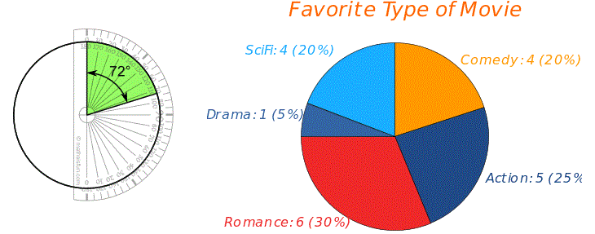

**Drawing a pie chart using Python!**

We have many ways to draw a pie chart by using python. Using the question above as an example.

1. One of the ways is using python turtle:

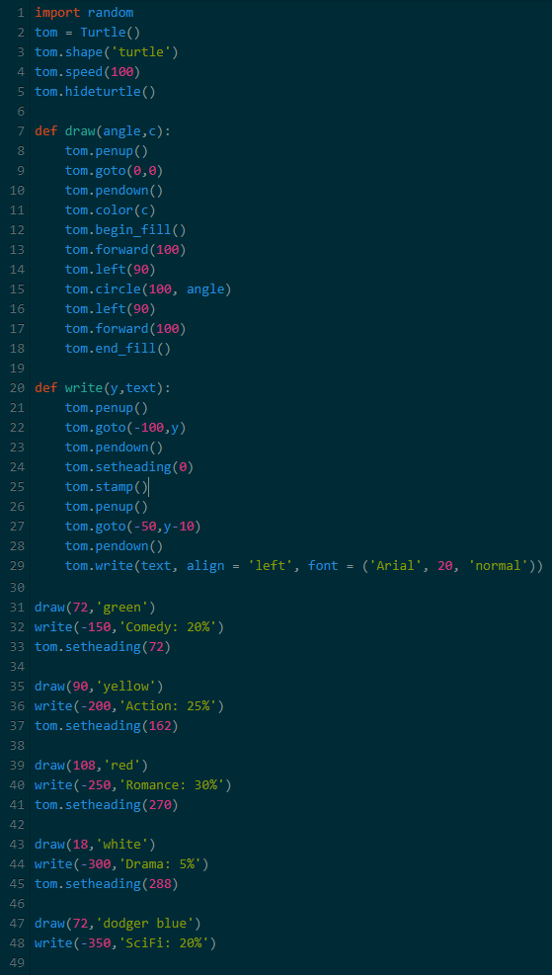 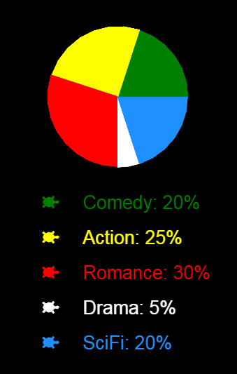

1. Another way is using Mathplotlib
2. By using Pandas

**Let’s get started to draw a pie chart with Mathplotlib library!**